Week 8: Database Relationship Analysis using Joins
Scenario:
The e-commerce company maintains customer, product, order, and payment details in separate tables. The management team uses SQL JOIN operations to connect these tables and customer orders, product sales, and payment transactions.
1. Implement INNER JOIN
Concept:
INNER JOIN combines rows from two tables when their related column values match. It displays only the records that have matching values in both tables.

Display customer details along with their orders.
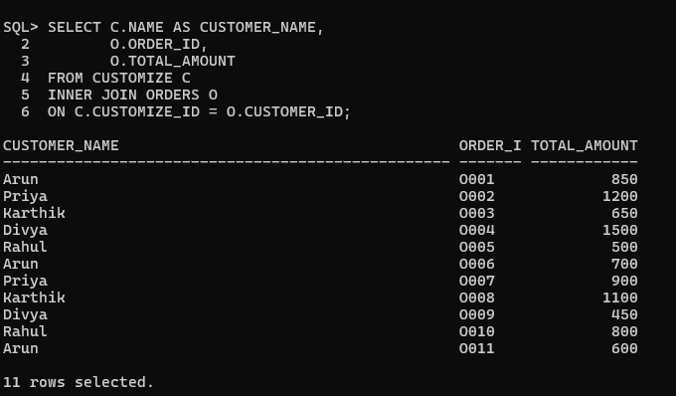

Display order details with payment information.

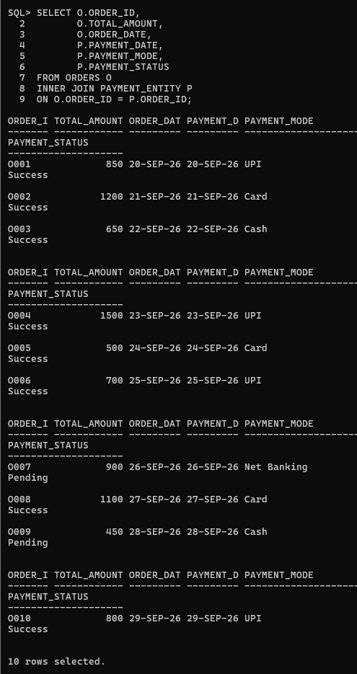

Retrieve products purchased by customers.
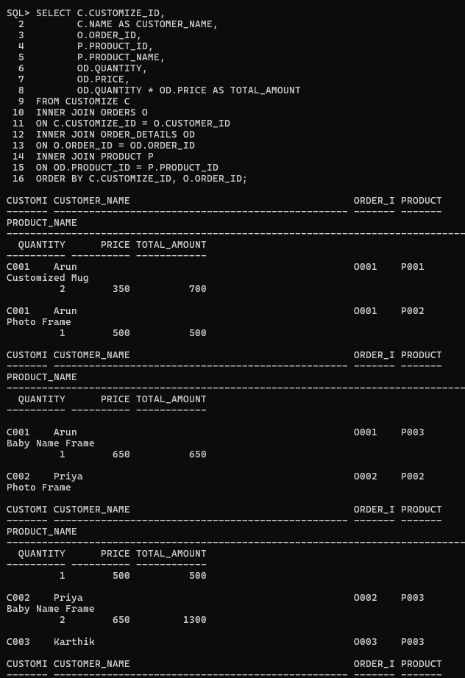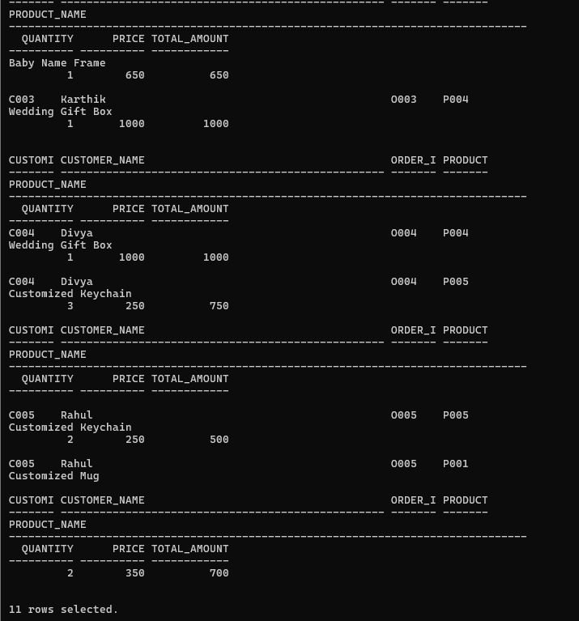

2. Implement LEFT JOIN
Display all customers, including customers who have not placed orders.
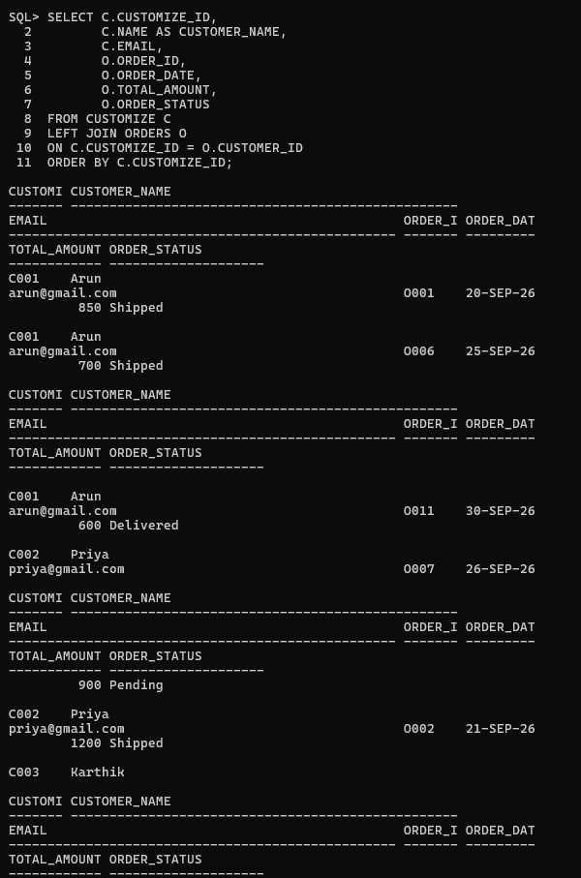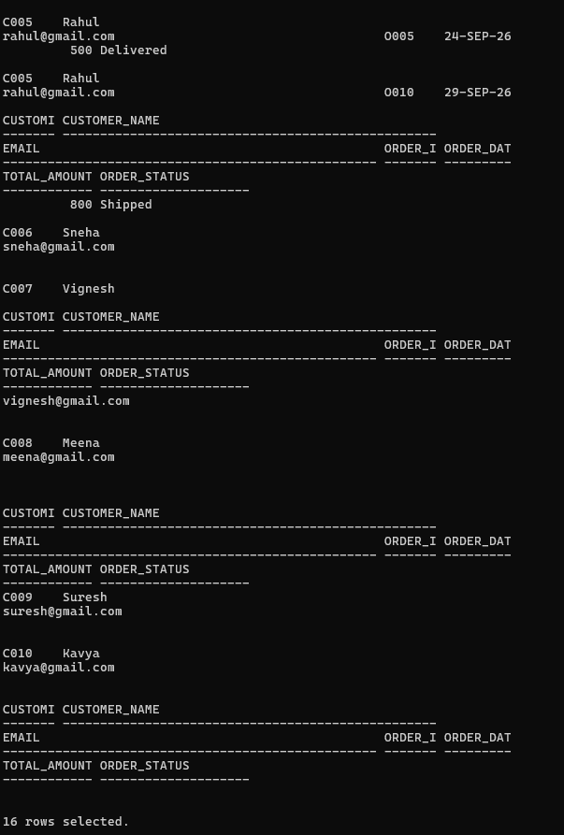
Find customers without any purchases.
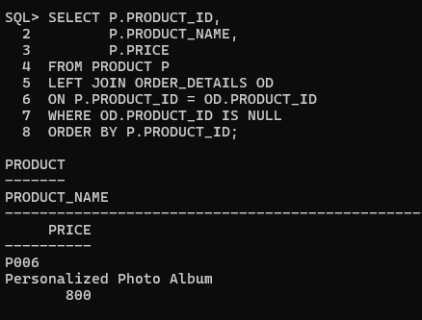
Display all products, including products with no sales.
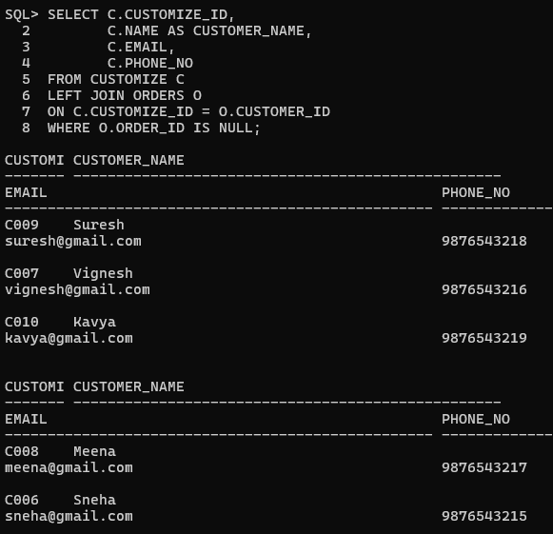

3. Implement RIGHT JOIN
Concept: RIGHT JOIN returns all records from the right table and matching records from the left table.
Display all orders with customer information.

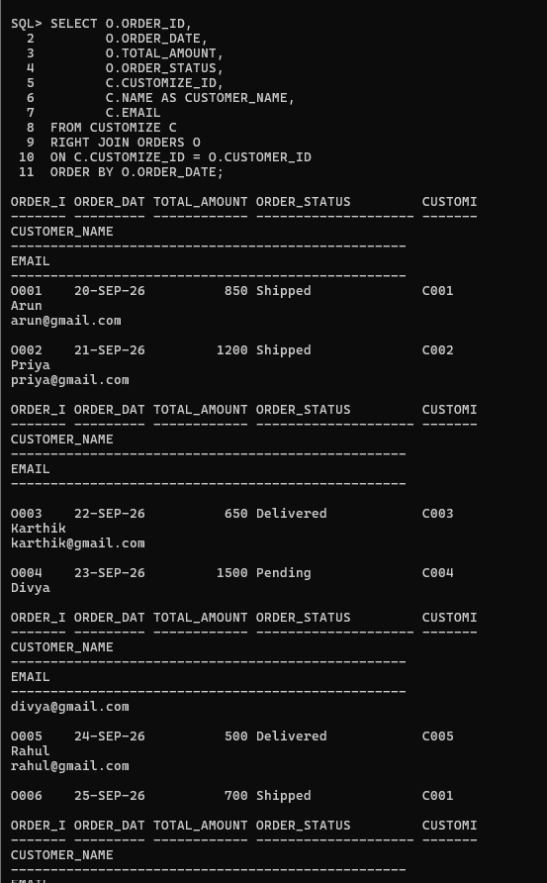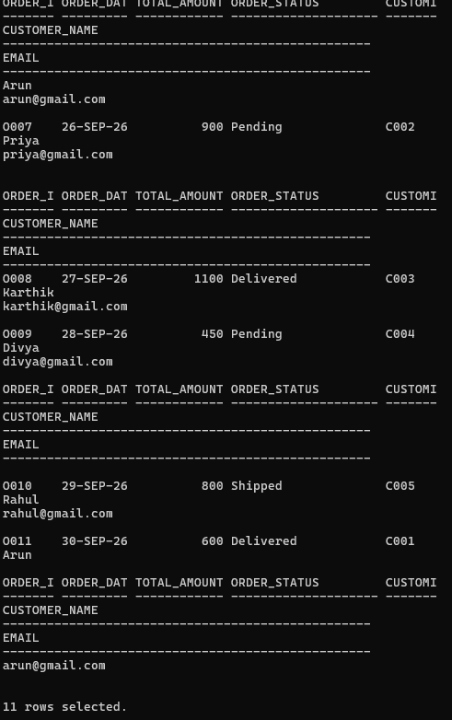
Find orders where customer details are missing.
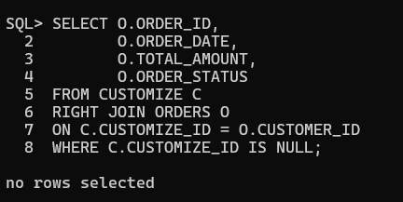
Display all payment records with order details
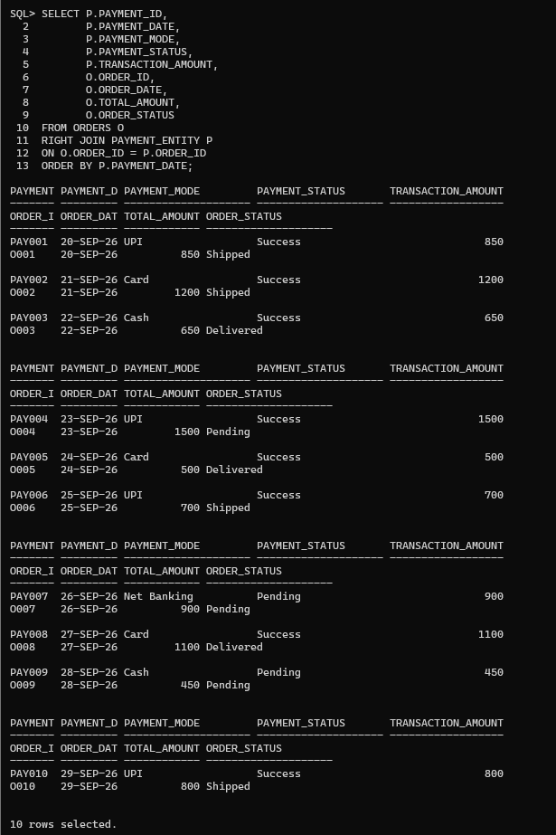.

4. Retrieve Complete Order Details
Generate a complete order report by combining customer name, product name, quantity, order date, total amount, and payment status.

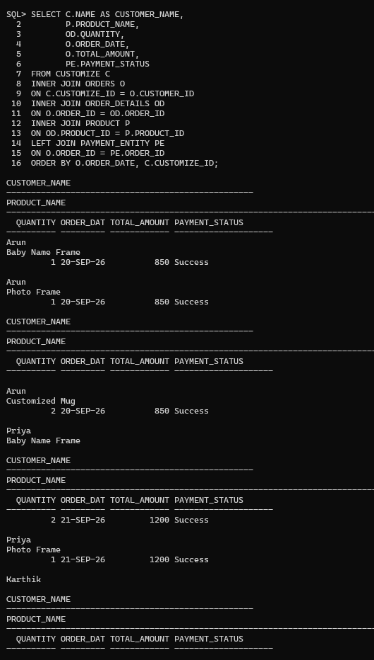
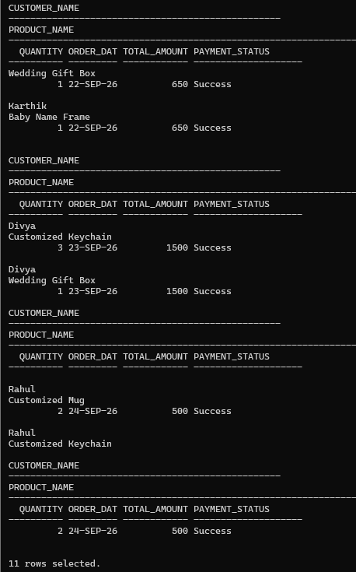
5. Display Customer Purchase History
Display all products purchased by a customer. 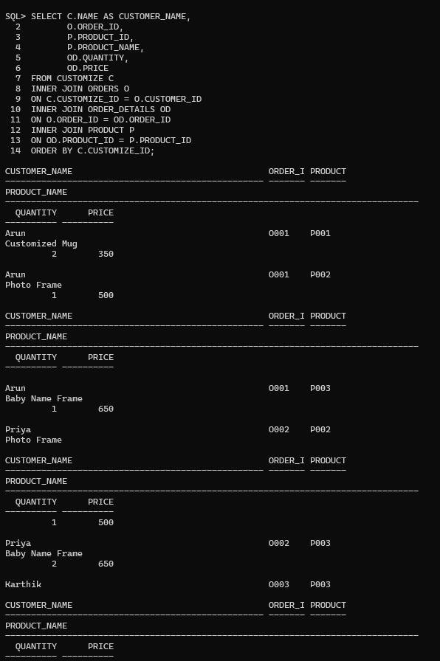
Find the total amount spent by each customer.
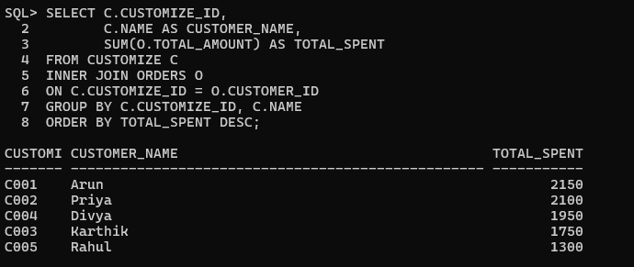

Find the number of orders placed by each customer.
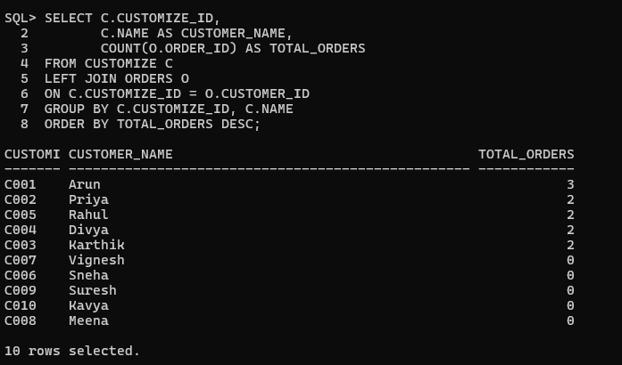

Display the latest purchase details of customers.
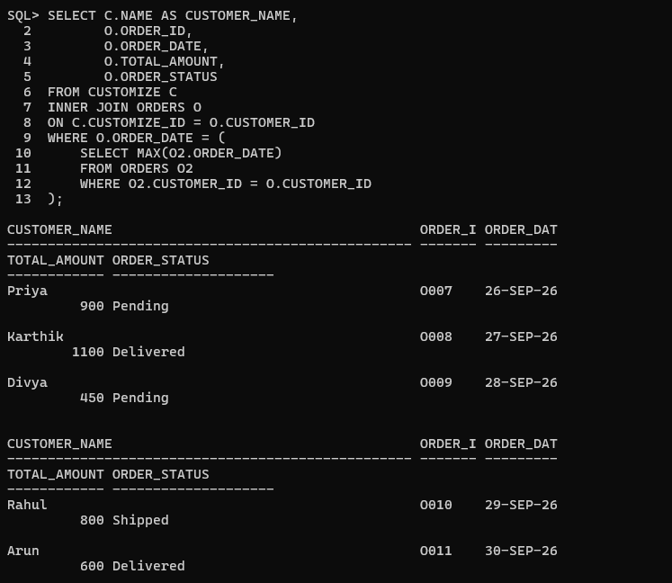

6. Generate Multi-Table Business Reports
Report 1: Customer Order Report
Display: Customer name, Order ID, Order date, Order status.
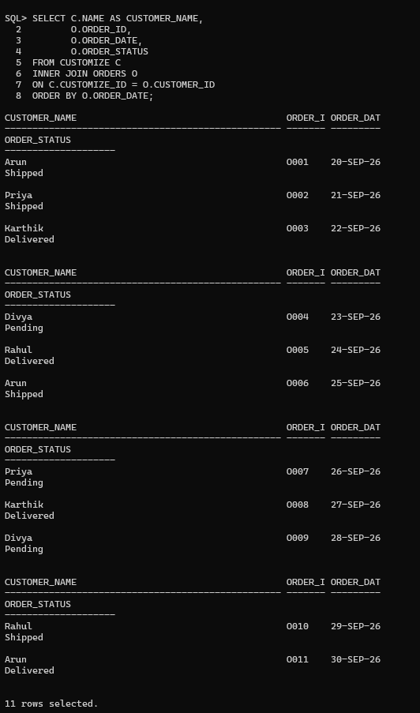

Report 2: Sales Report
Display: Product name, Quantity sold, Total revenue.

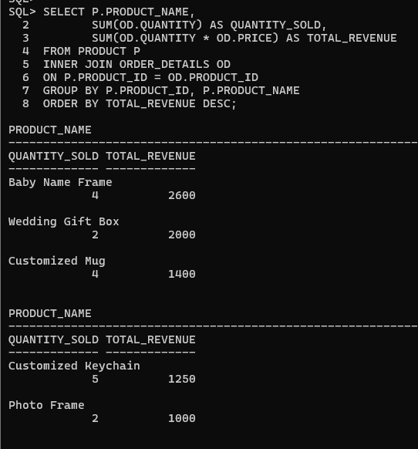
Report 3: Payment Analysis Report
Display: Payment mode, Number of transactions, Successful payments.
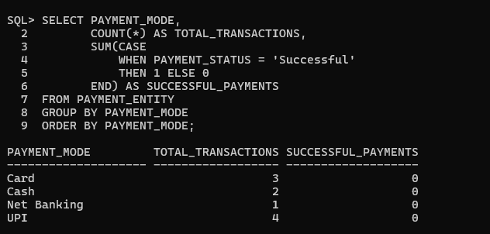
Report 4: Customer Purchase Analysis
Find top purchasing customers.
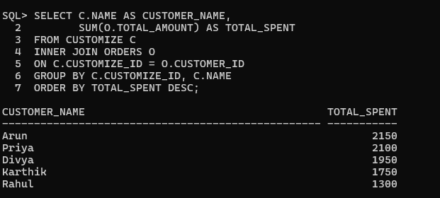
Find customers with maximum orders.
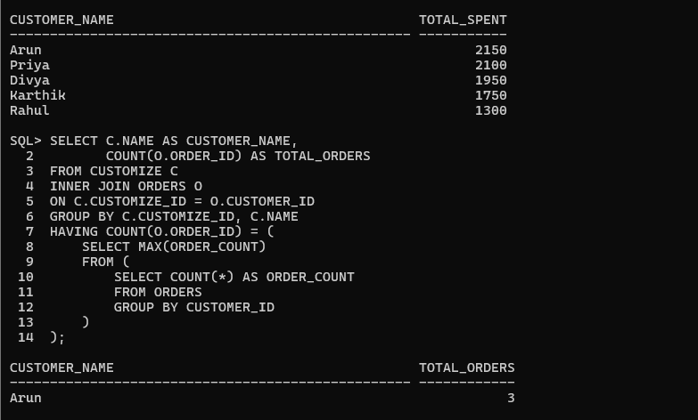

Find customers with highest spending.
